Case Study Report



**Tech Saksham**

Data Analytics with Power BI

**“360-degree Business Analysis of Online Delivery Apps”**

**“Government Arts and Science College, Aundipatti”**

|  |  |
| --- | --- |
| **NM ID** | **NAME** |
| ABC64CBDD1AB55EA22143D715918874D | NARENTHIRA PANDIYAN.P |

|  |  |
| --- | --- |
|  |  |
|  | Trainer Name : R.UMAMAHESWARI |
|  | Master Trainer : R.UMAMAHESWARI |

**ABSTRACT**

Online delivery apps have revolutionized the way consumers access goods and services, offering convenience and accessibility like never before. However, to thrive in this competitive landscape, businesses operating such platforms must continuously analyze and optimize their operations. This abstract presents a 360-degree business analysis framework utilizing Power BI application, aimed at providing valuable insights to online delivery app businesses.

The analysis begins by integrating various data sources such as transactional data, customer feedback, market trends, and operational metrics into the Power BI platform. Through interactive dashboards and visualizations, stakeholders gain a comprehensive understanding of key performance indicators (KPIs) across different facets of the business.

Key areas of analysis include customer behavior and preferences, order fulfillment efficiency, vendor performance, and revenue generation. By leveraging Power BI's advanced analytics capabilities, businesses can identify patterns, trends, and opportunities for improvement. For instance, identifying peak ordering times can optimize resource allocation and minimize delivery times, enhancing customer satisfaction.

Moreover, sentiment analysis of customer feedback enables businesses to gauge satisfaction levels and address any pain points promptly. Utilizing predictive analytics, businesses can forecast demand, optimize inventory management, and tailor marketing strategies to specific customer segments.

**INDEX**

|  |  |  |
| --- | --- | --- |
| **Sr. No.** | **Table of Contents** | **Page No.** |
| 1 | Chapter 1: Introduction | 4 |
| 2 | Chapter 2: Services and Tools Required | 7 |
| 3 | Chapter 3: Project Architecture | 9 |
| 4 | Chapter 4: Modeling and Result | 10 |
| 5 | Conclusion | 14 |
| 6 | Future Scope | 14 |
| 7 | GitHub Link | 15 |

**CHAPTER 1**

**INTRODUCTION**

* 1. **Problem Statement**

In the rapidly evolving landscape of online delivery apps, businesses face the challenge of efficiently managing operations, optimizing customer experiences, and staying competitive in a crowded marketplace. However, the absence of a comprehensive and integrated approach to business analysis often leads to fragmented insights and missed opportunities for improvement. To address this issue, there is a critical need for a robust framework that enables businesses to conduct a 360-degree analysis of their operations, encompassing customer behavior, vendor performance, operational efficiency, and revenue generation. This project aims to develop such a framework using Power BI application, enabling online delivery app businesses to gain actionable insights and make informed decisions to drive growth and success in the digital marketplace.

* 1. **Proposed Solution**

The proposed solution is to develop a Power BI dashboard that can analyze and visualize 360-degree business analysis of online delivery apps. The dashboard will integrate data from various sources such as Restaurant Count by Rating Color and demographic data. It will provide a comprehensive view of preferences and trends, enabling online delivery app to make informed decisions. The dashboard will be interactive, user-friendly, and customizable, allowing analysis of online delivery apps it to their specific needs. The capability of 360-degree business analysis of online delivery apps the dashboard will enable banks to respond promptly to changes in online delivery apps behavior or preferences, identify opportunities for cross-selling and up-selling, and tailor their products and services to meet customer needs.

* 1. **Feature**
* **Real-Time Analysis**: The dashboard will provide 360-degree business analysis of online delivery apps.
* **Trend Analysis**: The dashboard will identify and display trends in online delivery apps behavior.
* **Predictive Analysis**: It will use historical data to predict future online apps behavior.
  1. **Advantages**
* **Data Visualization:** Power BI provides powerful visualization tools that allow you to create interactive and insightful dashboards and reports. You can visualize key performance indicators (KPIs) such as order volumes, delivery times, customer satisfaction scores, and revenue trends in a way that is easy to understand and analyze.
* **Real-time Monitoring:** Power BI can be configured to pull in real-time data from your online delivery app's backend systems. This allows you to monitor key metrics and trends as they happen, enabling you to make timely decisions and respond quickly to changes in the business environment.
* **Mobile Access:** Power BI offers mobile apps for iOS, Android, and Windows devices, allowing you to access your reports and dashboards from anywhere. This means that decision-makers can stay informed and take action on the go, whether they're in the office, at home, or on the road.
* **Scalability:** Power BI is a scalable solution that can handle large volumes of data and support hundreds or even thousands of users. Whether your online delivery app is a small startup or a large enterprise, Power BI can scale to meet your needs and grow with your business.
* **Cost-Effectiveness:** Power BI offers flexible pricing options, including a free tier for small businesses and startups. This makes it a cost-effective solution for organizations of all sizes, allowing you to get started with minimal upfront investment and scale up as needed over time.
  1. **Scope**

The scope of the project "360-degree Business Analysis of Online Delivery Apps" utilizing Power BI encompasses a comprehensive examination of various facets crucial to the success and optimization of online delivery platforms. This analysis will delve into areas such as customer behavior, market trends, operational efficiency, revenue streams, and competitor insights. Through the power of Power BI's advanced analytics and visualization capabilities, the project aims to provide stakeholders with actionable insights to enhance decision-making processes, improve user experiences, and ultimately drive growth and profitability within the online delivery app ecosystem. By leveraging data-driven methodologies, this project seeks to offer a holistic perspective, enabling businesses to adapt strategies effectively and stay ahead in the rapidly evolving landscape of online delivery services.

**CHAPTER 2**

**SERVICES AND TOOLS REQUIRED**

**2.1 Services Used**

* **Power BI Desktop:** The primary tool for creating interactive reports and dashboards.
* **Power BI Service:** For sharing and collaborating on reports and dashboards in the cloud.
* **Data Sources:**

1. **Online Delivery Apps Data API:** API endpoints for accessing real-time data from online delivery apps such as orders, customer reviews, ratings, etc.
2. **SQL Server Database:** Storing historical data for in-depth analysis.

* **Power Query Editor:** Used for data transformation and cleaning tasks.
* **Data Modeling:** Creating relationships between different data tables to build a coherent data model.

**2.2 Tools and Software used**

**Tools**:

* **Power BI**: The main tool for this project is Power BI, which will be used to create interactive dashboards for real-time data visualization.
* **Power Query**: This is a data connection technology that enables you to discover, connect, combine, and refine data across a wide variety of sources.

**Software Requirements**:

* **Power BI Desktop**: This is a Windows application that you can use to create reports and publish them to Power BI.
* **Power BI Service**: This is an online SaaS (Software as a Service) service that you use to publish reports, create new dashboards, and share insights.
* **Power BI Mobile**: This is a mobile application that you can use to access your reports and dashboards on the go.

**CHAPTER 3**

**PROJECT ARCHITECTURE**

**3.1 Architecture**

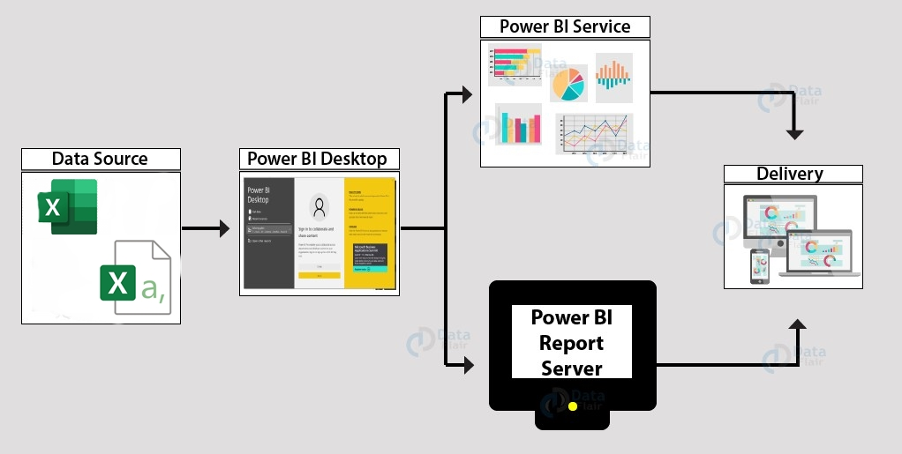

Here’s a high-level architecture for the project:

1. **Data Collection**: 360-degree Business Analysis of Online Delivery Apps data is collected from various Countries, various Cuisines, various Cities etc.
2. **Data Storage**: The collected data is stored in a database for processing. Azure SQL Database.
3. **Machine Learning**: Predictive models are built based on processed data using Azure Machine Learning. These models can help in predicting rating of various cuisines, detecting fraud, etc.
4. **Data Visualization**: The processed data and the results from the predictive models are visualized in real-time using Power BI. Power BI allows you to create interactive dashboards that can provide valuable insights into the data.
5. **Data Access**: The dashboards created in Power BI can be accessed through Power BI Desktop, Power BI Service (online), and Power BI Mobile.

This architecture provides a comprehensive solution for real-time analysis of bank customers. However, it’s important to note that the specific architecture may vary depending on the bank’s existing infrastructure, specific requirements, and budget. It’s also important to ensure that all tools and services comply with relevant data privacy and security regulations.

**CHAPTER 4**

**MODELING AND RESULT**

**Manage relationship:**

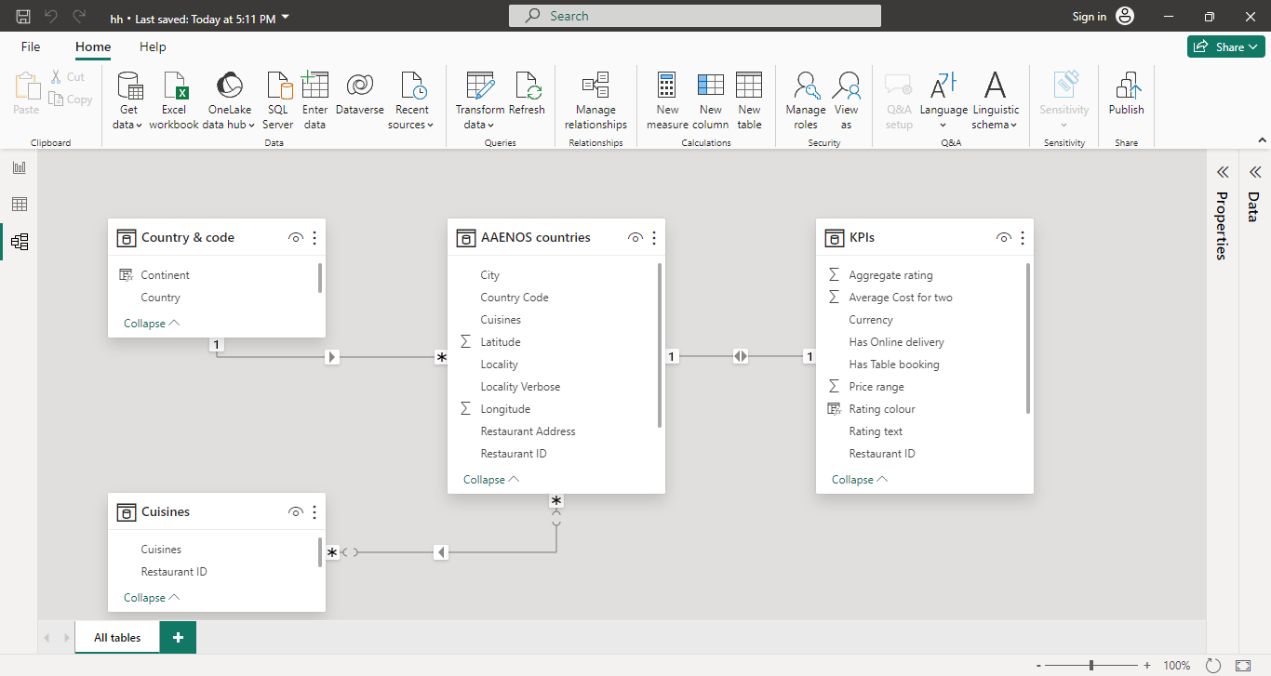

**CREATE A NEW COLUMN:**

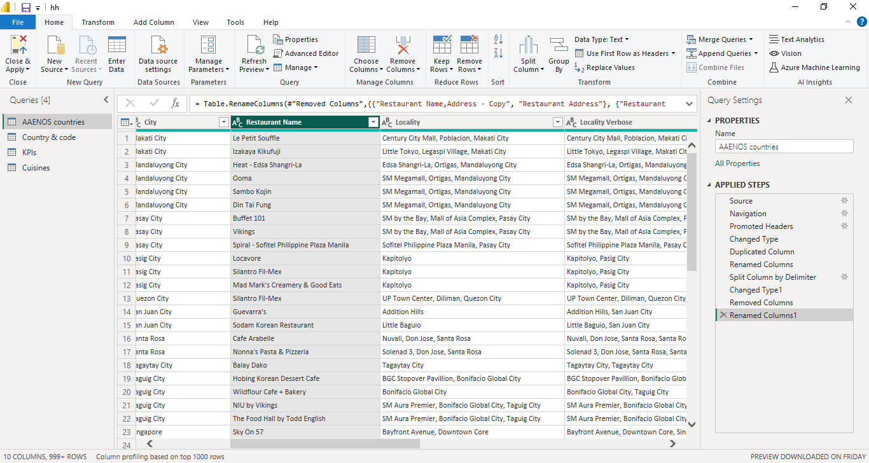

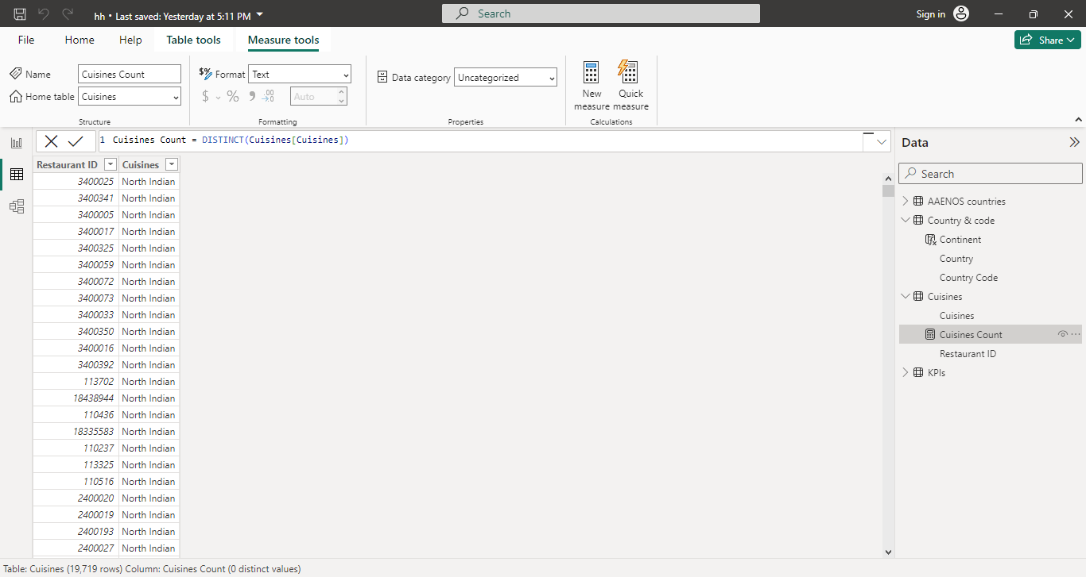

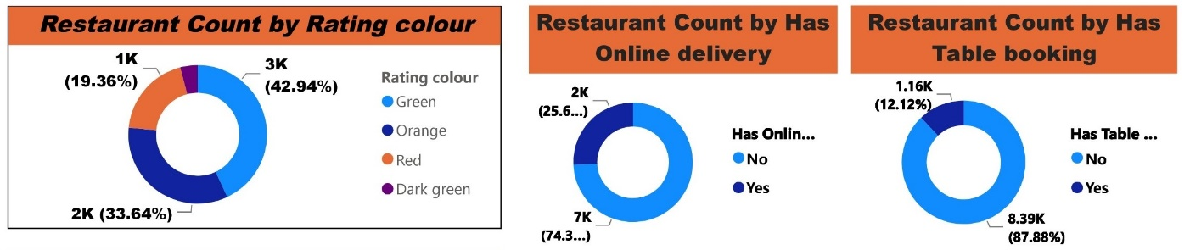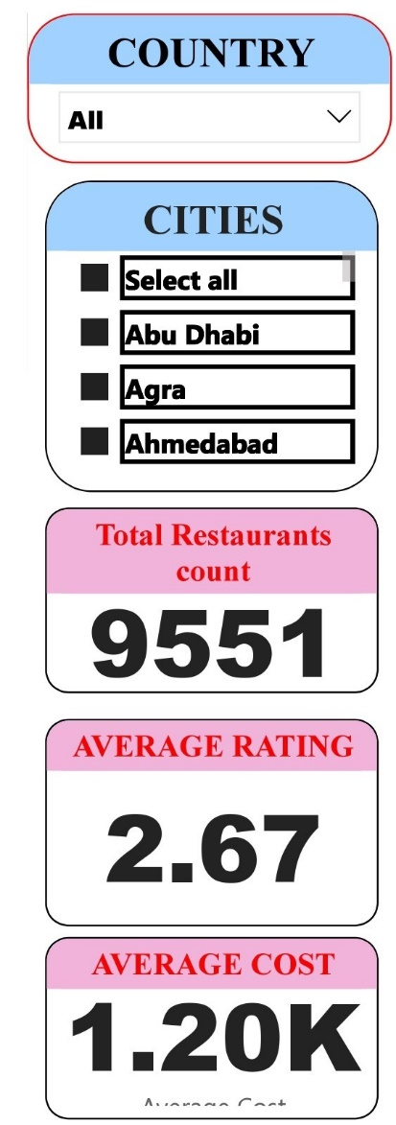**CHART WORKS:**

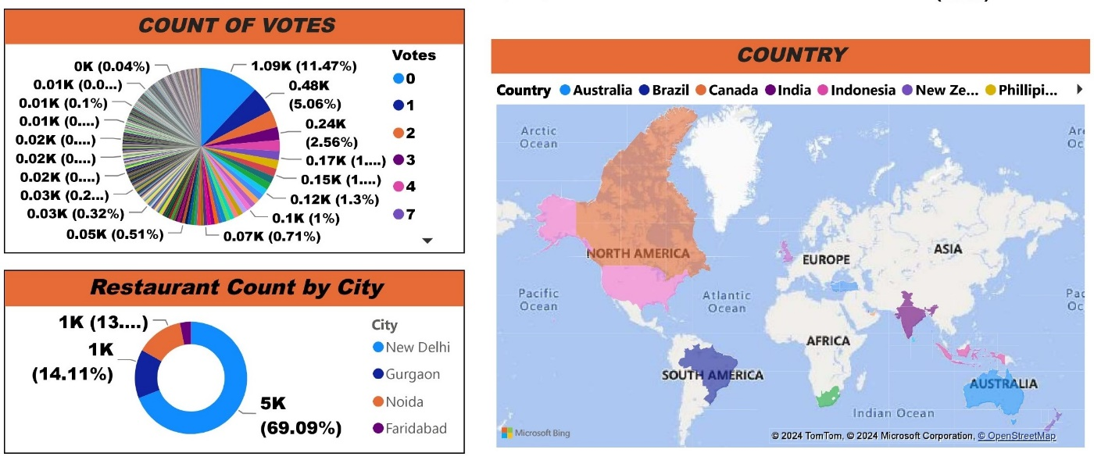

**DASHBOARD:**

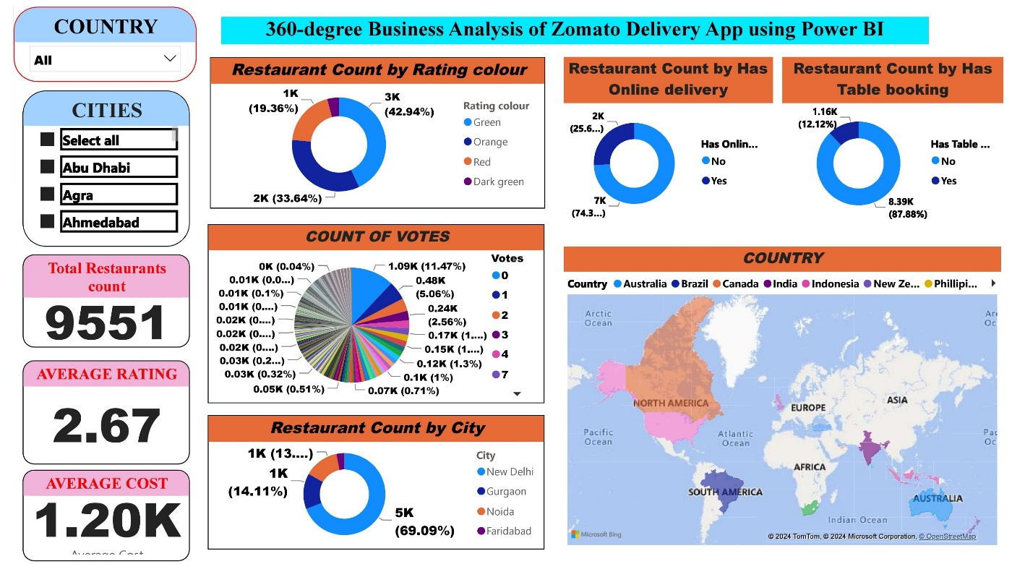

**CONCLUSION**

In conclusion, the project "360-degree Business Analysis of Online Delivery Apps" conducted through the utilization of Power BI application has provided comprehensive insights into the online delivery app industry. Through data visualization and analysis, we have gained a deeper understanding of market trends, customer behavior, and operational performance across various key metrics. By leveraging Power BI's capabilities, we were able to identify opportunities for optimization, such as enhancing user experience, streamlining operations, and maximizing revenue generation. This project underscores the importance of data-driven decision-making in the competitive landscape of online delivery services, empowering businesses to adapt and thrive in an ever-evolving market.

**FUTURE SCOPE**

The future scope of the "360-degree Business Analysis of Online Delivery Apps" project using Power BI application is promising and multifaceted. With continuous advancements in data analytics and visualization technologies, there are several avenues for expansion and enhancement. Firstly, the project can incorporate predictive analytics models to forecast customer demand, optimize delivery routes, and suggest personalized recommendations for users. Secondly, integrating machine learning algorithms can enable the system to detect patterns and anomalies in delivery operations, leading to improved efficiency and cost savings. Additionally, incorporating geospatial analysis capabilities can provide valuable insights into regional market trends, competitive landscapes, and demographic preferences. Furthermore, leveraging real-time data streaming capabilities can facilitate dynamic monitoring of key performance indicators, enabling stakeholders to make timely decisions and adapt to market changes swiftly. Finally, exploring the potential of augmented reality (AR) and virtual reality (VR) technologies can enhance the user experience by offering immersive interfaces for order tracking, menu browsing, and interactive customer support. Overall, the future scope of this project is extensive, with opportunities to leverage emerging technologies and methodologies to drive innovation and optimize business outcomes in the online delivery industry.

**GITHUB LINK**

[**https://github.com/asmku647c1s23096/NARENTHIRA-PANDIYAN-power-Bi**](https://github.com/asmku647c1s23096/NARENTHIRA-PANDIYAN-power-Bi)